Subject: Complaint Regarding Misrepresentation – Request for Immediate Resolution
From:Rewired Rewired (re_wired@ymail.com)
To:enquiries@livingandhome.co.uk
Date:Friday 20 June 2025 at 17:51 BST
Dear Living and Home Customer Service,
I am writing to formally raise a complaint concerning a product I purchased on 18 June 2025 via your website.
Firstly, your product listing creates a misleading impression of the item being sold. The product is titled “Elegant and Functional Electric Fireplace TV Stand with Modern Features” (SKU: PM1672), and the title’s description suggests that the purchase includes both the TV stand and the electric fireplace.
Secondly, the main images prominently display the TV stand alongside the fireplace insert. The combination of the title and images, which present both components as a single item for sale, along with the pricing, leads one to believe that they are purchasing the entire unit. This creates a misleading impression that the complete unit is being sold, rather than just the fireplace insert. After thoroughly reviewing the listing, I realised why I felt misled before making my purchase. The structure of your site contributed to this confusion, as it gave the impressin that I was buying the entire unit.
There Are Two Options Shown Beneath the Product:
- “Fireplace TV Stand” – which is greyed out and unavailable,
- “Fireplace Only” – which was in a constant selected mode!
At no point during the checkout process did the product title or page make it clear that I was only purchasing the fireplace insert. The warnings were greyed out alongside other information about items not included in the purchase, which contributed to my misunderstanding. Additionally, the images and title suggested that I was acquiring more than just the insert.
Importantly, there is no option to purchase just the TV cabinet separately. This creates confusion, as even if the option for the fireplace and TV stand were available, I would end up with two fireplace inserts. From my understanding, the cabinet shown in the images cannot be purchased independently. This lack of clarity has been particularly confusing for me as a first-time buyer from your store.
This lack of clarity in the product structure constitutes a material omission, and your listing fails to meet the standard of clear and unambiguous communication required under the Consumer Protection from “Unfair Trading Regulations 2008.” In particular, “Regulation 5” and “Regulation 6” prohibit misleading actions or omissions that cause the average consumer to make a transactional decision they would not otherwise have made. That is precisely what has occurred here.
I made this purchase in good faith, believing I was buying a complete fireplace TV stand as presented. Instead, I received only the insert, which is not usable on its own, rendering the purchase not fit for purpose for a first-time consumer.
I respectfully request the following:
A full refund, including a return method to be arranged not at my expense, and
Written acknowledgment that the product was misrepresented.
I am prepared to escalate this matter to “Trading Standards” and initiate a dispute with my payment provider if a resolution is not offered promptly. I trust this will not be necessary and hope you will address this issue with the urgency and fairness it deserves.
I await your reply.
Yours sincerely, Mr. Simon Paul Cordell

[Living and Home] Re: Subject: Complaint Regarding Misrepresentation – Request for Immediate Resolution
From:Living and Home (Living and Home) (support@livingandhome.zendesk.com)
To:re_wired@ymail.com
Cc:enquiries@livingandhome.co.uk
Date:Saturday 21 June 2025 at 03:12 BST
Your request (67292) has been updated. To add additional comments, reply to this email.
Dear Mr. Simon Paul Cordell,

Thanks for your message.

We have checked your order: 109978. The product you purchased is Black / Fireplace Only SKU: PM1672

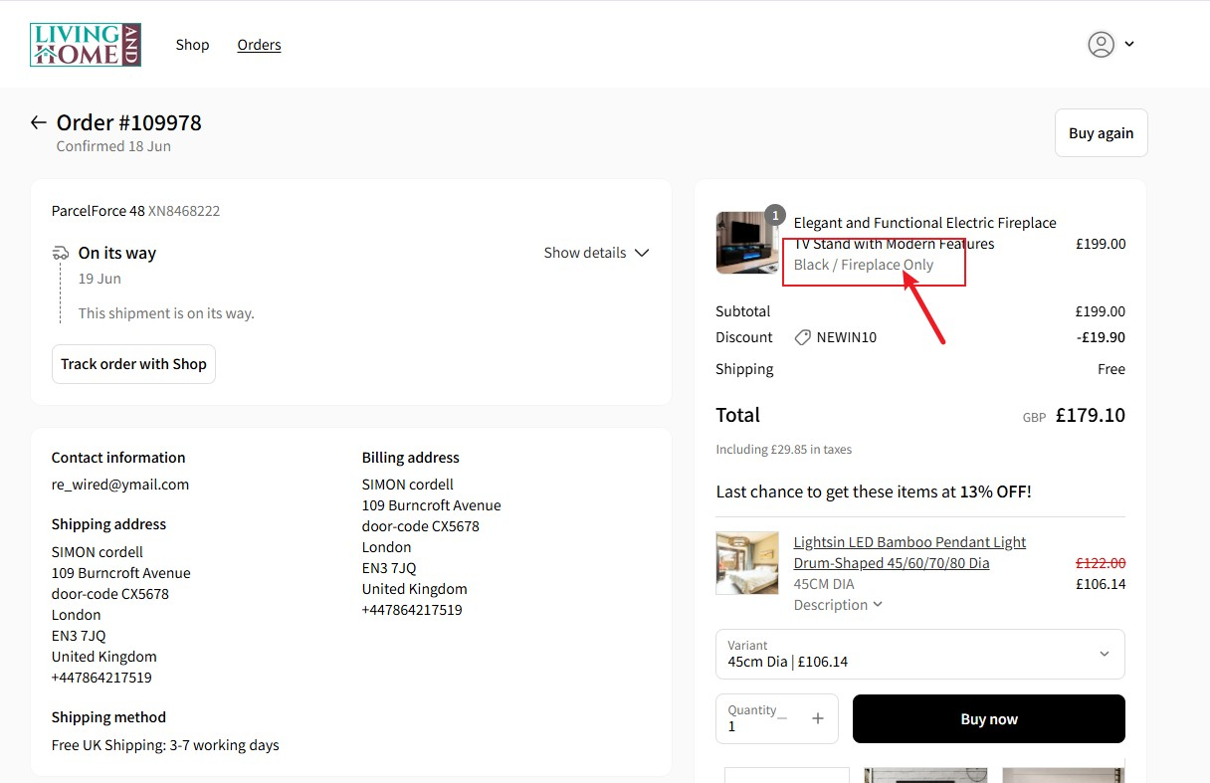

We need to clarify that the products we sell do not mislead consumers. Our product titles are: ”Elegant and Functional Electric Fireplace TV Stand with Modern Features”

The products in this product link include TV stands and fireplaces, but each customer will have two options when purchasing: a. "Fireplace TV Stand"

b. "Fireplace Only"

This can be purchased according to the needs of consumers. We provide customers with two options.

As for the option of the "Fireplace TV Stand" you mentioned, it is grayed out and unavailable.
This is because this product is out of stock. "Fireplace Only" has been available because we have inventory for this product and can ship it.

We can know from your description that you also knew that the option of the "Fireplace TV Stand" was grayed out and unavailable when you purchased it, so you could not check this option and buy a "Fireplace TV Stand".

You chose the option of "Fireplace Only".

Our product pages and options clearly indicate the product, so there is no misleading, and there is no selling of wrong products.

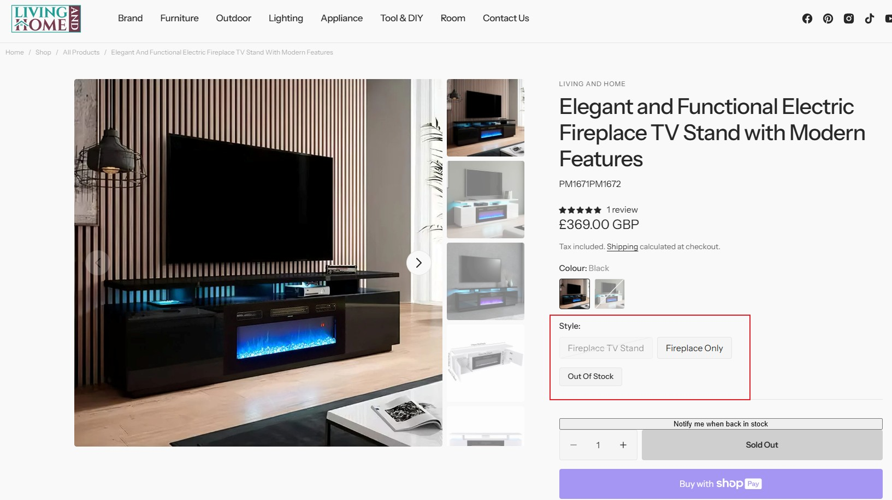

If you don't like the product you purchased, we will be happy to provide you with a full refund, but according to our return policy, if there is no quality problem with the product we sold, the customer will be responsible for the return cost.
https://www.livingandhome.co.uk/pages/returns-policy

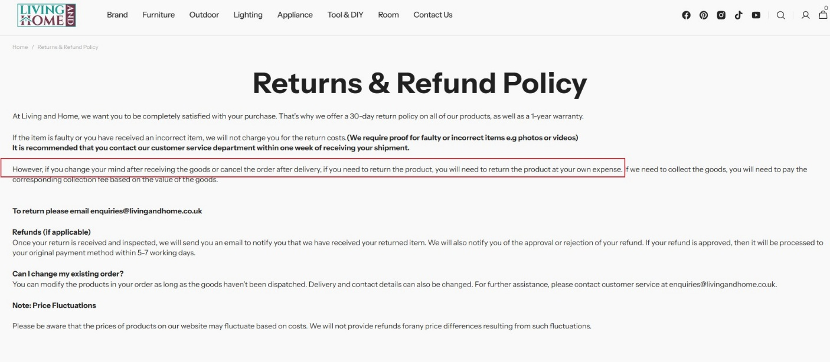

Hope you can understanding.

If you have any questions, please feel free to contact us.

Best Regards, Moy
Warm regards
Living and Home

Subject: Follow-Up on Misrepresentation – Clarification and Request for Fair Resolution Order ID: 109978
To: Living and Home (Customer Service)
From: Mr. Simon Paul Cordell

Hello Moy, Customer Services for Living and Home,
I would like to thank you for your reply, and I appreciate your time. I would like to clarify a few errors you have stated that you have since based your verdict upon based upon my email of complaint.
My email and online chat with a live assistant was logged as a complaint and I do not feel that you have handled it as such, as you have not addressed the issues I raised fairly but rather used them incorrectly to obtain your decision for me not to be obviously entitled to a free refund. I do not want this support from yourselves to turn into a legal battle of avoidance by yourselves, when I as the consumer have faced issues from the company you and your teams represent.

You state: > “We have checked your order: 109978. The product you purchased is Black / Fireplace Only SKU: PM1672”

...and you provide a screen shot! This statement feels like trickery as the product I bought does not say “Black Fireplace” as the title. It in fact states: “Elegant and Functional Electric Fireplace TV Stand with Modern Features”, and underneath the title it states “Black / Fireplace Only” but the “Black / Fireplace Only” is “Grayed Out In Text.
Visual Evidence & Admission Of Misleading Design.”

Furthermore, your own email admits: > “As for the option of the ‘Fireplace TV Stand’ you mentioned, it is grayed out and unavailable. This is because this product is out of stock.”
This directly confirms that Living and Home purposely uses “Greyed-Out Font Styles” to indicate “inactive or unavailable options.” That very styling was also applied to “Black / Fireplace Only” at the time of my purchase.
To demonstrate this clearly, I’ve included two screenshots:
- The product page does not state “Black / Fireplace Only” in o below the title or images. The next page opened once you click buy now is where you find the text “Black / Fireplace Only” and is below the title of product which displays the “Main Title” in bold black (#000000) font, clearly indicating prominence. As Exhibited as Exhibit “01” here:

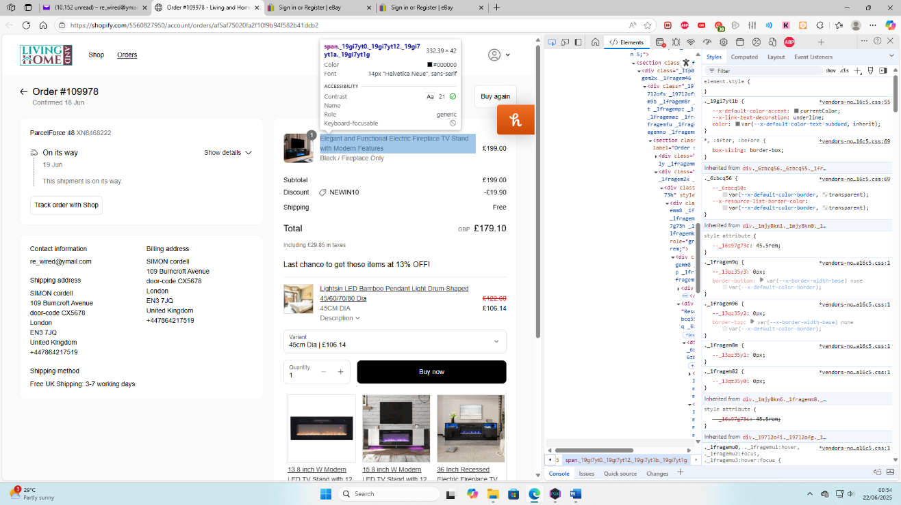

- Just below that, “Black / Fireplace Only” is rendered in grey (#707070)—visually matching the “unavailable “Fireplace TV Stand” option. As Exhibit “02” here:
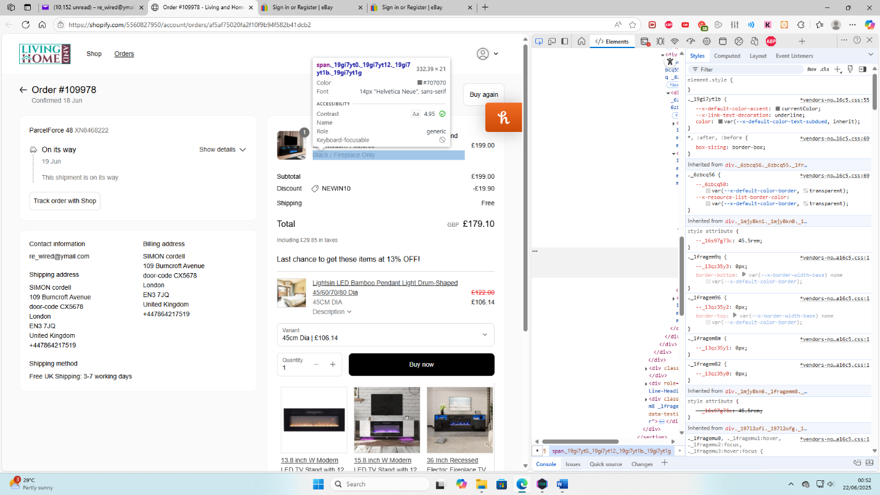

These grey tones are consistently used on your site to signal inaccessibility or exclusion. As such, any reasonable consumer, especially one unfamiliar with your interface—would perceive the grey “Fireplace Only” label as either an unselected option or an informational note about stock status.
Combined with the “Product Imagery,” which shows the TV stand and fireplace together, and the “Lack Of Any Option To Purchase The Stand Separately,” this led me to a “Transactional Decision I Would Not Have Made” had the listing been clearly presented.

This fulfills the definition of a “Misleading Omission,” and potentially a “Misleading Action,” under the Consumer Protection from Unfair Trading Regulations 2008 (Regulations 5 & 6).

Resolution Requested:
As a result, I respectfully request the following:
- A full refund, including return costs not to be borne by myself.
- Written acknowledgment that the product listing was misleading at the time of my order.

I am willing to resolve this directly with you, but I am fully prepared to submit my case to Trading Standards and my card issuer should resolution not be reached.
I trust this summary will allow you to reassess the facts impartially.

Kind regards, Mr. Simon Paul Cordell

